Software Requirement Specifications
Daily Deals and Discounts



Submitted by
MUHAMMAD FAHAD
F22BINFT1M01074

Submitted to
Dr. Musarat Karim

Department of Information Technology
Faculty of Computing
The Islamia University of Bahawalpur

Meeting Details
Sr No | Details | Date | Supervisor Signature
Summary
The Daily Deal and Discounts system is a web-based platform designed to help users discover the best local deals, discounts, and offers available in their nearby area. Local vendors can post deals for products and services, while customers can search, filter, and locate these offers using categories, location, and price ranges.
This SRS document outlines the system’s purpose, scope, functional and non-functional requirements, user characteristics, and system processes. The project aims to bridge the communication gap between local businesses and customers, ensuring a fast, accessible, and user-friendly solution.

Table of Contents
1. Introduction 5
1.1. Purpose 5
1.2. Scope 5
1.3. Product Perspective 6
1.4. User Characteristics 6
1.5. Similar apps and systems/Literature Review 6
1.6. Proposed Technologies 6
2. Requirements 7
2.1. Function Requirements 7
2.2. Non-Functional Requirements 9
3. Use Cases and Flow of Processes 10
3.1. Use Case 001- Sign Up 11
3.2. Use Case 002- Login 13
3.3. Use Case 003- Post a Deal 15
3.4. Use Case 004- Search & Browse Deals 17
3.5. Use Case 005- View Deal Details 19
3.6. Use Case 006- Save or Report Deal 21
3.7. Use Case 007- Approve / Reject Deal 23
4. References 25

- Introduction
Consumers often struggle to find reliable local deals from nearby businesses. Local vendors also lack simple platforms to promote special offers digitally. The Daily Deals and Discounts web platform solves this problem by connecting customers and vendors in one virtual marketplace where real-time deals can be posted, viewed, and filtered easily.
  - Purpose
The purpose of this project is to build a web system that allows:
- Vendors to post deals, discounts, and promotional offers.
- Customers to browse, search, and locate nearby deals.
- The system to ensure validity, visibility, and user engagement.

  - Scope
Included Features
- User registration & login (Vendor & Customer).
- Vendor dashboard to add, edit, and manage deals.
- Customer interface to browse deals by category, location, or search keywords.
- Geo-location based deal suggestions.
- Ratings & feedback on deals.
- Admin panel for moderation and user management.
Excluded Features
- Online payment system.
- Delivery or order booking functionality.
- Vendor financial statistics beyond deal analytics.

  - Product Perspective
This system is a standalone web application consisting of three modules:
- Admin module (deal and user moderation)
- Vendor module (deal posting and management)
- Customer module (deal searching and viewing)

  - User Characteristics
User Type | Technical Level | Responsibilities
Admin | Intermediate | Approving deals, managing users, monitoring activities
Vendor | Basic | Posting offers, updating deals, viewing analytics
Customer | Basic | Searching, filtering, reviewing deals

  - Similar apps and systems/Literature Review
Similar existing platforms include:
- PakWheels Classifieds → Local listings but no dedicated deals system.
- OLX → General marketplace but lacks discount-focused features.
- Google Maps Offers Section → Limited vendor control in local regions.
Gap identified: none provide a dedicated local deal posting and discovery platform for small vendors.

  - Proposed Technologies
- • Frontend: HTML5, CSS3, JavaScript, React.js
- • Backend: Node.js / Express.js
- • Database: MySQL or MongoDB
- • Tools: GitHub, VS Code,
- • Deployment: Firebase / Netlify / Render / VPS

- Requirements
The system allows customers to search local deals while vendors manage their offers. Vendors can create deals by entering product name, description, discount percentage, expiry date, and location. The admin verifies and manages users and deals to ensure quality.
  - Function Requirements

FR001 – User Sign Up
Name: Sign Up
Purpose: To register new users into the system.
Users: Admin, Vendor, Customer
Input:
- Full Name
- Email
- Password (8 characters, must include a number)
- Location
- Phone Number (11 digits)
- Account Type (Vendor/Customer)
Output:
- The user receives an account creation confirmation. Vendors may require admin approval.

FR002 – Vendor Login
Purpose: Allows vendors to access the dashboard.
User: Vendor
Input: Email, Password
Output: Vendor dashboard with deal-management options
FR003 – Post a Deal
Purpose: Vendors add new deals.
Input:
- Deal Title
- Description
- Discount %
- Original & Discounted Price
- Location
- Deal Expiry Date
- Product Image
Output: New deal added to system and awaits admin approval.

FR004 – Customer Deal Search
Purpose: Customers browse deals.
Input:
- Search keywords
- Category
- Location
- Price range
Output: Filtered list of deals.

FR005 – Admin Approval
Purpose: Admin moderates deals and user accounts.
Input: Deal posts, reports, user details
Output: Approved/rejected deals, activated/deactivated accounts.

  - Non-Functional Requirements
NFR001 – Performance
- System should load deals within 3 seconds.
- Supports up to 500+ concurrent users.

NFR002 – Security
- Password hashing must be implemented.
- Input validation for all forms.

NFR003 – Usability
- User-friendly and mobile-responsive interface.

NFR004 – Reliability
- System uptime should be at least 99% during active hours.

NFR005 – Scalability
- Database designed to handle growing vendor and user data.

- Use Cases and Flow of Processes
Use cases are the formal representation of process flow defined by functional requirements. Here I provide a flow of events in this. This is a system level use case which is directly influenced to project functions with their actors (customer, vendor and admin).
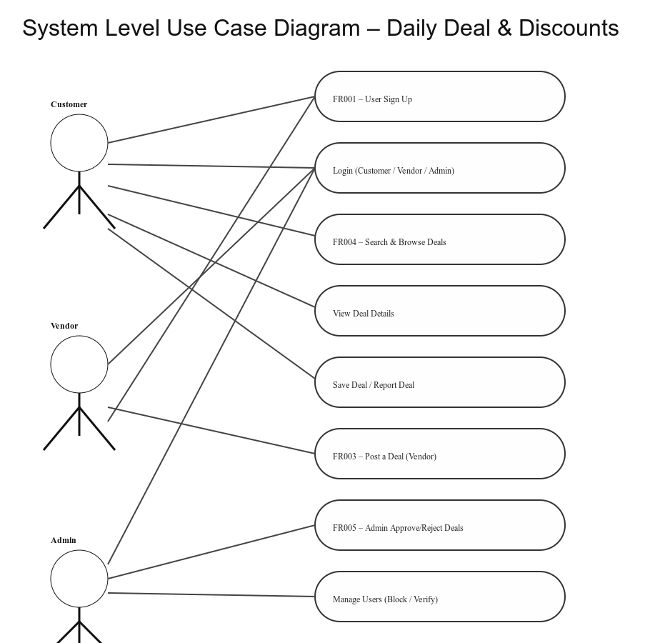
Figure 1: System Level Use Case Diagram

  - Use Case 001- Sign Up
ID | UC001
Name | Sign Up
Description | This use case describes how a Customer or Vendor registers an account in the Daily Deal & Discounts system.
Requirement(s) | FR001
Actor(s) | Customer, Vendor
Precondition | User must not already have an account in the system.
Postcondition | Customer account becomes active; Vendor account awaits Admin approval.
Basic Flow | Basic Flow  1. User opens the Sign Up page.  2. User enters required information.  2.1 Required fields:  2.1.1 Name  2.1.2 Email  2.1.3 Password  2.1.4 Phone  2.1.5 User Role (Customer/Vendor)  3. System validates input fields.  3.1 Email format validation  3.2 Password must be ≥ 8 characters  3.3 Phone number must be valid  4. System creates new user account.  5. System displays a confirmation message.  Alternative Flow  1. Vendor registers → Account goes to “Pending Admin Approval”.  2. Admin manually approves vendor profile later.  Exceptions  1. Invalid inputs.  2. Email already exists.  3. System unable to respond.

Diagram:
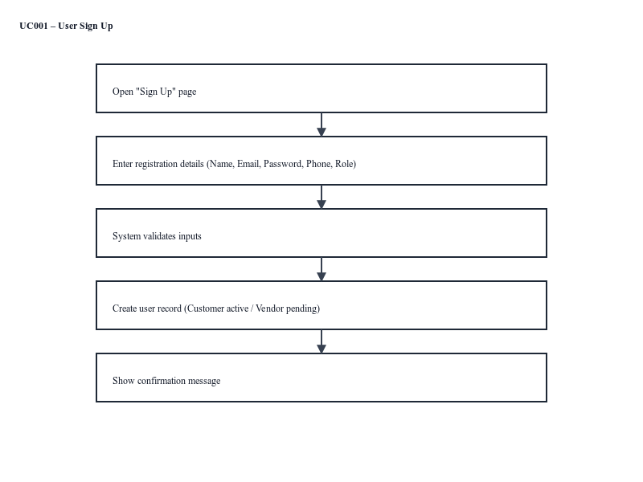
Figure 2: Use Case001- Sign Up

  - Use Case 002- Login
ID | UC002
Name | Login
Description | This use case describes how a Customer, Vendor, or Admin logs in.
Requirement(s) | FR001
Actor(s) | Customer, Vendor, Admin
Precondition | User must have an active account.
Postcondition | User is redirected to their respective dashboard.
Basic Flow | Basic Flow  1. User enters Email and Password.  2. System validates credentials.  3. System checks user role.  4. System redirects user:  4.1 Customer → Customer Dashboard  4.2 Vendor → Vendor Dashboard  4.3 Admin → Admin Panel  Alternative Flow  1. Forgot Password → User resets password using email link.  Exceptions  1. Invalid credentials.  2. Blocked/deactivated account.  3. System error.

Diagram:
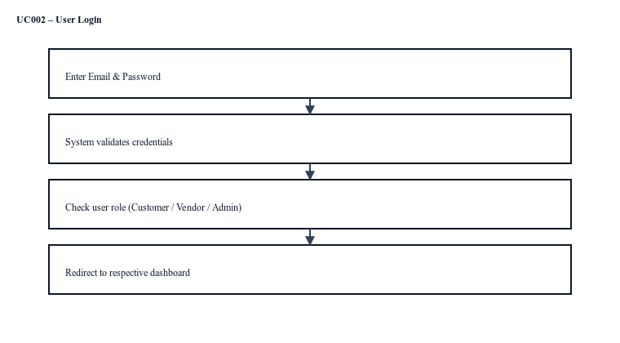
Figure 3: Use Case002- Log In

  - Use Case 003- Post a Deal
ID | UC003
Name | Post a Deal
Description | This use case describes how a Customer or Vendor registers an account in the Daily Deal & Discounts system.
Requirement(s) | FR003
Actor(s) | Vendor
Precondition | Vendor must be logged in.
Postcondition | Deal status becomes "Pending Review".
Basic Flow | Basic Flow  1. Vendor opens “Create New Deal”.  2. Vendor enters deal details:  2.1 Title  2.2 Description  2.3 Original & Discounted prices  2.4 Discount percentage  2.5 Location  2.6 Expiry date  3. System validates fields and uploaded images.  4. System stores deal as “Pending Review”.  5. Vendor receives confirmation.  Alternative Flow  1. Vendor edits a previously rejected deal and resubmits.  Exceptions  1. Missing fields.  2. Invalid price/discount.  3. Image format not supported.

Diagram:
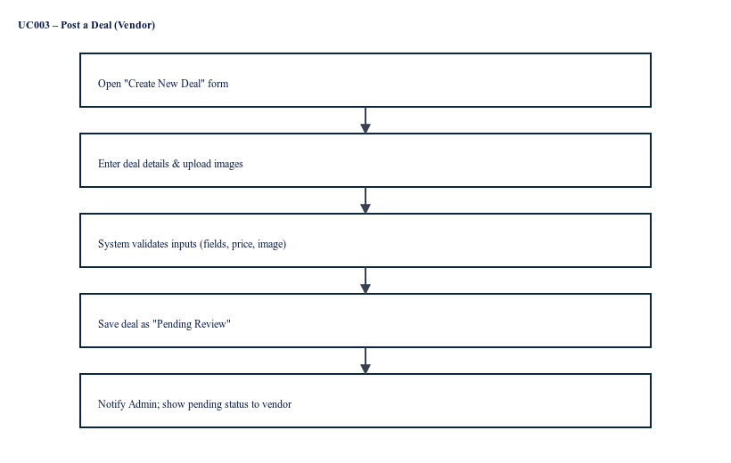
Figure 4: Use Case003- Post a Deal

  - Use Case 004- Search & Browse Deals
ID | UC004
Name | Search & Browse Deals
Description | Customer searches for deals using various filters.
Requirement(s) | FR004
Actor(s) | Customer
Precondition | Customer must be logged in.
Postcondition | Matching deals are displayed.
Basic Flow | Basic Flow  1. Customer opens Deals page.  2. Customer applies filters:  2.1 Location  2.2 Category  2.3 Price range  2.4 Keyword  3. System fetches matching deals.  4. System displays filtered deals.  Alternative Flow  - Customer view deals without filters (default listing).  Exceptions  1. No deals found.  2. System unable to load results.

Diagram:
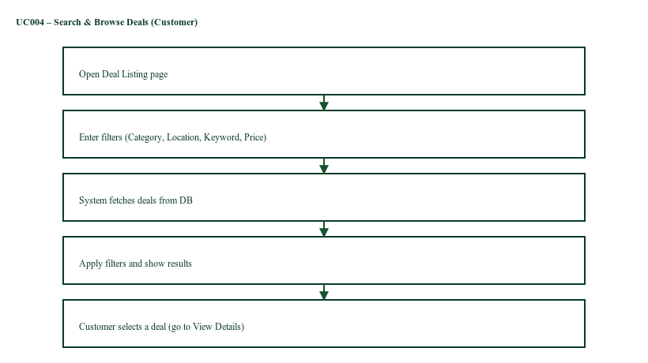
Figure 5: Use Case004- Search & Browse Deals

  - Use Case 005- View Deal Details
ID | UC005
Name | View Deal Details
Description | Shows detailed information about a selected deal.
Requirement(s) | FR004
Actor(s) | Customer
Precondition | Deal must be active.
Postcondition | Customer views complete details.
Basic Flow | Basic Flow  1. Customer selects a deal.  2. System loads deal details:  2.1 Vendor info  2.2 Discount  2.3 Location  2.4 Expiry date  3. System shows deal page.  Alternative Flow  1. Customer views related/recommended deals on the same page.  Exceptions  1. Deal expired.  2. Deal removed by Admin.

Diagram:
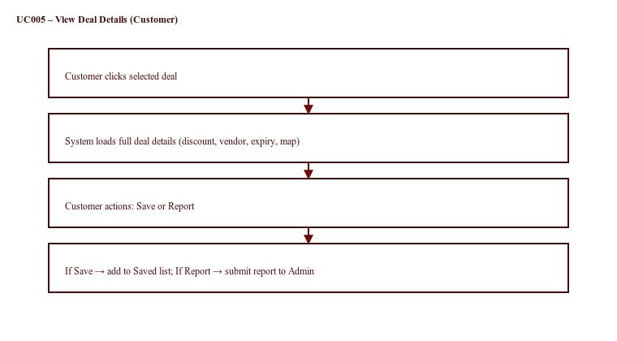
Figure 6: Use Case005- View Deal Details

  - Use Case 006- Save or Report Deal
ID | UC006
Name | Save or Report Deal
Description | Customer saves a deal for later or reports it for issues.
Requirement(s) | FR004
Actor(s) | Customer, Admin
Precondition | Customer must view a valid deal.
Postcondition | Deal is saved OR report sent to Admin.
Basic Flow | Basic Flow  1. Customer clicks “Save Deal”.  2. System adds deal to Saved List.  OR  3. Customer clicks “Report Deal”.  4. Customer selects report reason.  5. System sends report to Admin.  Alternative Flow  - Customer unsave a deal.  Exceptions  1. System fails to save deal.  2. Report submission fails.

Diagram:
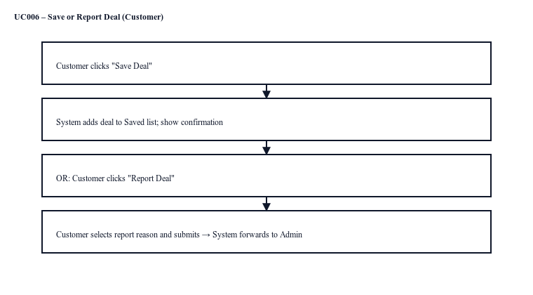
Figure 7: Use Case006- Save or Report Deal

  - Use Case 007- Approve / Reject Deal
ID | UC007
Name | Approve / Reject Deal
Description | Admin reviews posted deals and approves or rejects them.
Requirement(s) | FR005
Actor(s) | Admin
Precondition | Deal must be in "Pending Review" status.
Postcondition | Deal becomes Active or Rejected.
Basic Flow | Basic Flow  1. Admin opens Pending Deals.  2. Admin selects a deal.  3. System shows deal details.  4. Admin approves or rejects the deal.  5. Vendor receives notification.  Alternative Flow  1. Admin requests clarification from vendor before approval.  Exceptions  1. Admin cannot load deal.  2. System error during status update.

Diagram:
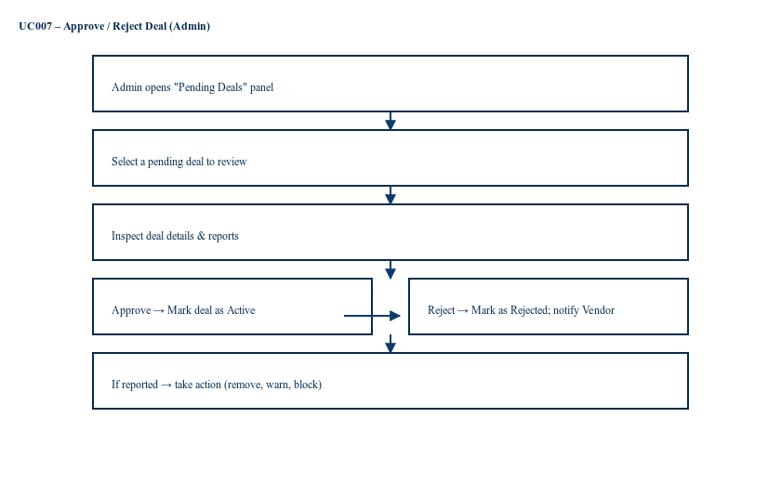
Figure 8: Use Case007- Approve/Reject Deal

- References
- IEEE Software Requirements Specification Guidelines
- Websites and apps used in literature review (OLX, Google Local Offers, etc.)
- React.js and Node.js official documentation

